Administration for Community Living Office of Healthcare Information and Counseling
Managing Through COVID-19 WorkgrouP - September 2020

Getting Ready for a Virtual Counseling Session
Preparing for Remote Medicare Open Enrollment Toolkit

Contents
Introduction 1
Google Drive 1
OneNote 2
Plan Comparison Tool 4
Scheduling a Remote Counseling Session 9

Introduction
Counseling virtually can seem overwhelming, but it doesn’t have to be. The trick is to be well organized and have the counseling session planned in advance. The resources shared are not all-inclusive, but they are useful applications that are easily accessible and free to use. The purpose of these applications is to help counselors store and share documents, organize files, and work with the Plan Finder Tool at Medicare.gov.

Google Drive
When individuals are counseling from home or other remote workspaces, they need easy access to all necessary documents (brochures, forms, instructions, etc.) for counseling. Google Drive serves as a cloud-based system in which documents may be created, stored, easily accessed, and shared with others. For example, the Nebraska SHIP program has created a Google Drive in which they create, upload and store needed documents. The program shares this link with counselors so they may access these documents with ease from any location.

Google Drive provides easy to access document creation and storage capabilities while working remotely.
Benefits of Using Google Drive
- It is free to create and use; you simply need a Gmail account.
- Only the person creating the Drive needs a Gmail account; others will be able to “view” the Drive without a Gmail account.
- Google Drive is accessible from anywhere you have an internet connection and is stored online. You only need a link to access it.
- You can set the security levels on specific documents. These documents can be edited, commented on, or just viewed depending on your preference.
- Drive offers products like Microsoft Word (Google Docs), Excel (Google Sheets) and PowerPoint (Google Slides).
- You can create documents, or you can upload documents that have been already created.
- When using a document created in Google Drive, such as a Google Sheet (spreadsheet), multiple people can access and edit the document at the same time. Changes are automatically saved.
  - For example, the Nebraska SHIP program uses a Google Sheet to schedule appointments for Open Enrollment. This allows all people with access to the link to make appointments simultaneously without accessing the state network.

For a demonstration on how to use Google Drive, check out the links below:
Google Drive has many features. To best understand this option and learn about how to use the system, watch the YouTube video and read the article linked below.
- How to Use Google Drive – Beginner’s Guide (Video)
https://www.youtube.com/watch?v=EbVnObwFJic
- How to Use Google Drive (Article) https://www.digitaltrends.com/computing/how-to-use-google-drive/

OneNote
OneNote is available without cost to users of Microsoft Office and Microsoft 365. Users of computers with Windows operating systems can find the OneNote application by typing “OneNote” into the search feature at the bottom of the screen. The program will prompt users to sign into an existing Microsoft account upon opening.
OneNote 10 is stored in the Cloud, which allows users to synchronize OneNote with other devices, such as an iPhone or iPad. Individuals can create multiple digital notebooks for various tasks or job responsibilities. Because it is in the Cloud, a notebook can be shared with staff or counselors within or outside of an agency. Once shared, content in notebook can be accessed or edited. The owner of the notebook decides the level of access for other users, including whether these users can edit or only view content. If the individual makes additions or edits to the notebook, OneNote automatically places the initials of the person beside the text that was inserted or edited.
Invite others to view or co-author a notebook
- In OneNote for the web, open the notebook you want to share.
- Click File > Share > Share with People.
- In the left column, under Share, make sure Invite People is selected.
- In the To box, type the email address of the person you want to invite.
- In the box below, type a brief note for the recipient so they have proper context for your invitation (for example: “Here is a link to my OEP planning notebook. Feel free to add anything I’ve missed!”).
- By default, recipients can make changes to the notebooks they are invited to. If you only want them to view, but not edit, the contents of your notebook, click the blue Recipients Can Edit link to change the permission settings.
- When you’re ready to send your notebook invitation, click Share.

Create a notebook link to share with others
If you don’t have the email addresses of the people you want to invite to view or edit your notebooks, or if you don’t want to use email for this purpose, you can easily create a custom link that lets you share notes with others.
- In OneNote for the web, open the notebook you want to share.
- Click File > Share > Share with People.
- On the left, under Share, click Get a link.
- Copy and then paste this link wherever your intended audience (for example, your blog readers) can see and click it to gain access to your notebook.
You can send an email to be stored on your OneNote. This helps to organize the emails and it makes locating information within an email much easier. Information you place within OneNote is automatically saved. You can record meetings and embed PDFs, PowerPoints, Word or Excel documents, or videos within the page of the OneNote. You can share more than one notebook. For example:

One notebook might contain all the application materials you may need while counseling remotely.

Another notebook could contain specific information about Medicare Advantage plans.

Another notebook could contain all the training materials with updates.

Another notebook could be for counselor meetings. Each meeting could be recorded, and the recording of the meeting could be embedded in the page with the PowerPoint for anyone who may have missed the meeting.
OneNote 16 is still available for use. It is can be stored on your computer, on your agencies’ shared drive, or in the Cloud. In-kind professionals or staff with work computers might consider using OneNote 16 to keep track of counselor related information when it is stored on a server or computer. OneNote16 has most of the features of OneNote 10, but it is more secure for storing personal information.

For a demonstration on how to use OneNote, check out the links below:
- Start Using OneNote (Video)
https://www.microsoft.com/en-us/videoplayer/embed/RWj0zu?pid=ocpVideo0-innerdiv-oneplayer&postJsllMsg=true&maskLevel=20&market=en-us
- A Beginner’s Guide to Microsoft OneNote (Video)
https://youtu.be/JEJZbjcMkeU
- Microsoft OneNote – Detailed Tutorial (Video)
Https://youtu.be/zjfIMCRJUAo

Plan Comparison Tool
Creating a PDF of the Plan Comparison and sending through Email
Sharing plan comparisons with beneficiaries is an essential aspect of Open Enrollment counseling. When counseling remotely, the plan comparison must be provided by email or mail. Email is the best option, provided the beneficiary can receive email.
The Medicare Plan Finder at medicare.gov does not currently offer an email option for plan comparisons, but comparisons can be turned into a PDF file and manually emailed to beneficiaries. Here are step-by-step instructions.

Compare the three options in Medicare.gov.
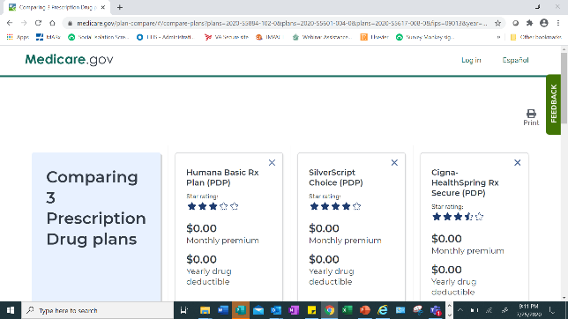
Click “Print.”

Under “Destination,” click “Save as PDF.”
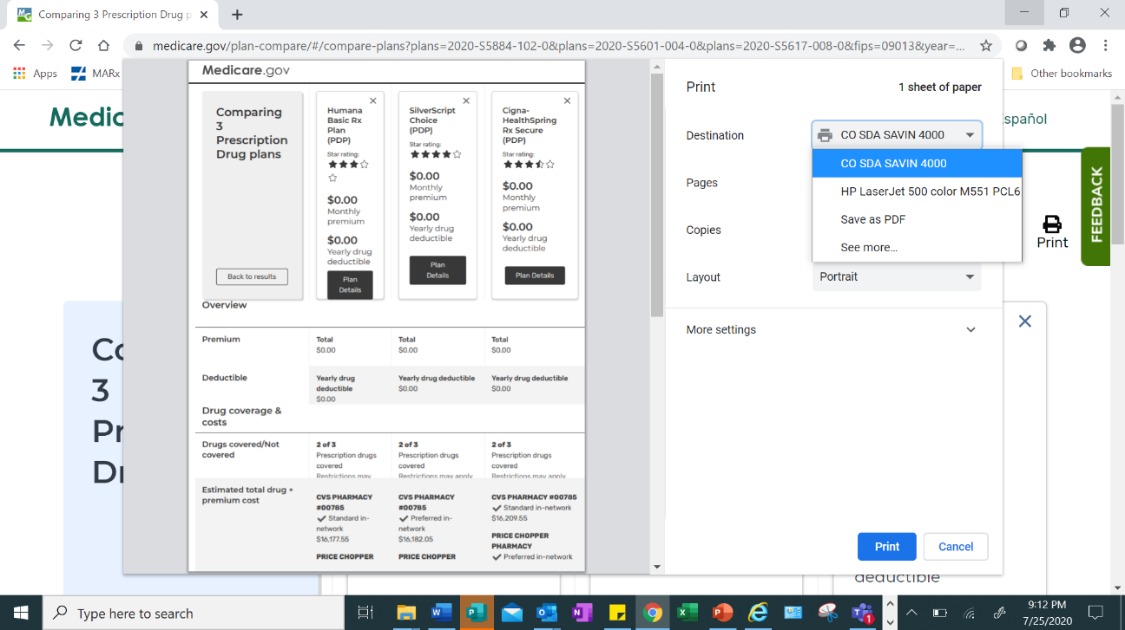

Save as a PDF onto your computer. Create a folder entitled “Temporary” or “Medicare Comparisons.”
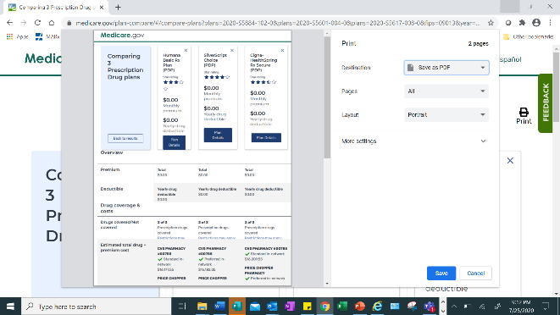

Name the file:
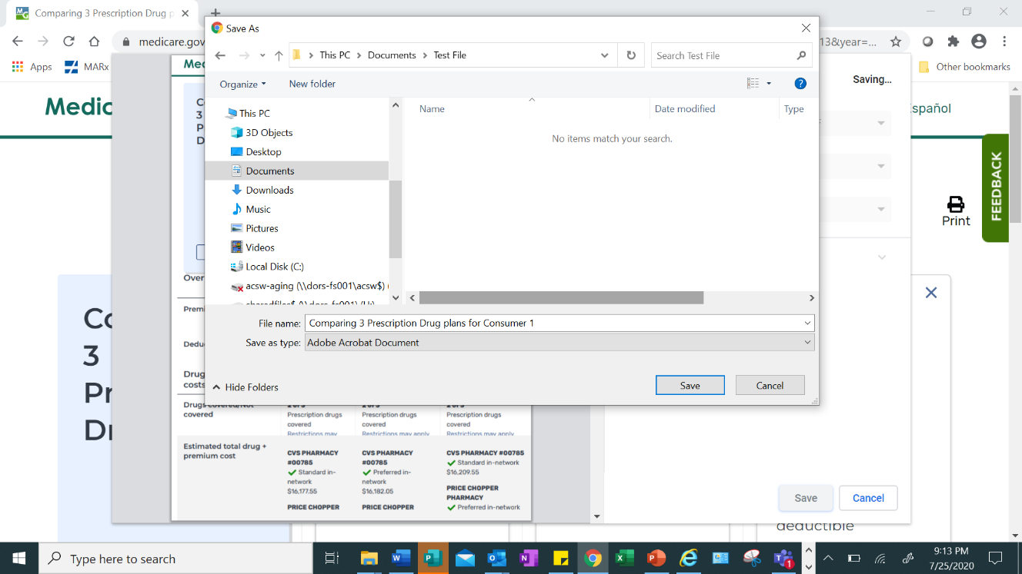

Open the PDF file:
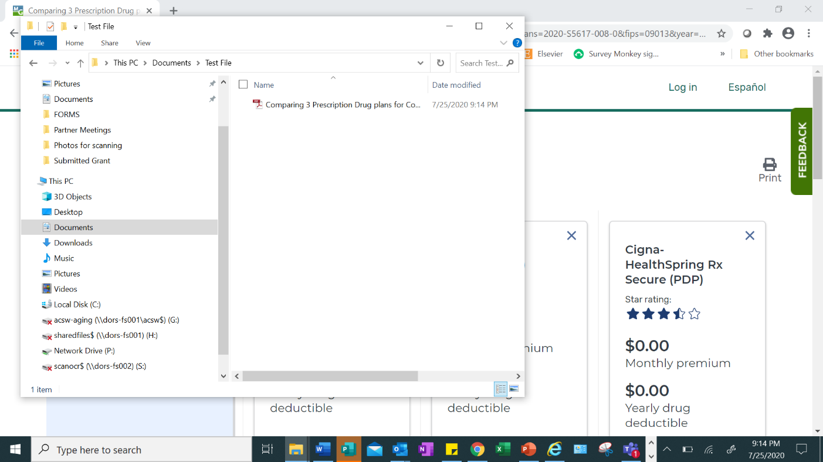

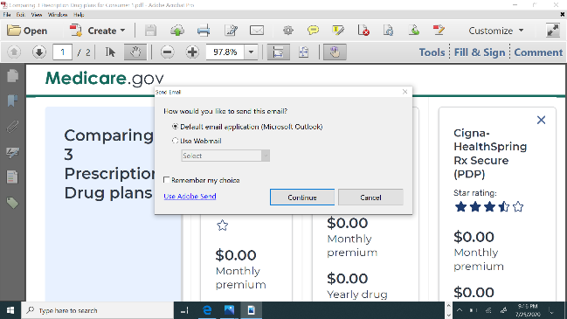
Click onto the envelope icon to send an email.

Enter the beneficiary’s email address, and the PDF will be automatically ready to email.

Other Destination Options:
When the three-plan comparison appears, select ”Print.” Under “Destination,” scroll to “Fax” or “Send to OneNote.”
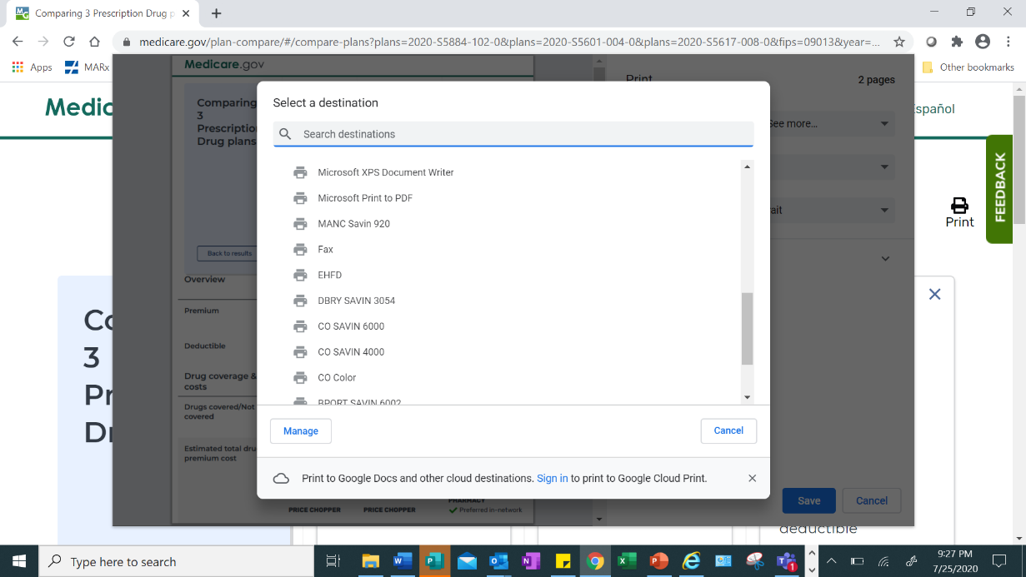

Tips to keep in mind:
If you use Outlook 365, sending PDF files from Adobe applications can be tricky. If using Outlook Webmail, look in the “Drafts” folder. If using the application, you may need to deactivate the setting for “Cached Exchange Mode“(which can affect performance), and then look in the “Drafts” folder.

Scheduling a Remote Counseling Session
Now that you have prepared for the remote counseling session by conducting plan comparisons, it is time to schedule time to meet virtually with the beneficiary.

Scheduling Checklist
- Set the appointment time and provide the beneficiary with the counselor’s name. Inform the beneficiary that the counselor will be using a scrambled personal cell number. The beneficiary should make sure to pick up the restricted or unknown call at the appointed time, as counselors cannot leave messages with a call back number. Tell beneficiaries that their appointment may be more than 60 minutes in length.
- Gather beneficiary’s email address, if available. Send PDF or link to any relevant documents information about plans available in area, plan comparisons, etc.)
- If the beneficiary is not comfortable using email, mail the packet of information to beneficiary’s physical address.
- Ask the beneficiary to take the call in a quiet, place free from background noise or other distractions.
- Remind the beneficiary to have their list of prescribed medications and Medicare number ready, or MyMedicare.gov account access information if available.
- Remind the beneficiary that they will be receiving documents before the call and ask them to make sure they can access these documents during the session.
- Ask the beneficiary to cancel their appointment if they no longer need help.

https://support.microsoft.com/en-us/office/use-onenote-for-the-web-to-share-notes-with-other-people-d3481fbe-e06c-4883-b7e9-b2ee9f38aed3
https://support.microsoft.com/en-us/office/use-onenote-for-the-web-to-share-notes-with-other-people-d3481fbe-e06c-4883-b7e9-b2ee9f38aed3

