eFile ID Process
eFile IDs are unique IDs assigned to every STARS/SHIP and SIRS/SMP user. eFile IDs are required by API submissions in order to assign STARS/SHIP and SIRS/SMP records to the desired user. The ID entered on the “eFile” field (STARS/SHIP) and “sirsEfileID” (SIRS/SMP) field will determine which user gets selected on the front-end Session Conducted By field. The Session Conducted by field subsequently determines the Partner Organization Affiliation and alignment of the record.
Note: SIRS/SMP eFile IDs are only necessary for implementation that will use the Send to SIRS/SMP functionality. This functionality takes the relevant fields entered on STARS/SHIP forms and uses them to simultaneously create a SIRS/SMP record.

API UAT Environment (https://hhs-sirs-uat.entellitrak.com)

Guidance for System Developers
  - Test eFile IDs are located in the API Authentication Credentials document. This document will contain two test accounts for the UAT environment, one SHIP and one SMP Team Member. Please log into the accounts with the credentials provided
Note: Test credentials in the UAT environment are created at the SHIP Director and SMP Director role level. This gives developers the ability to create additional users and fully test their implementations by simulating Production
  - Navigate to the SHIP Team Member profile of the user desired via the SHIP Team Member Tracking Inbox or SHIP Team Member search. Locate the SHIP eFile ID field
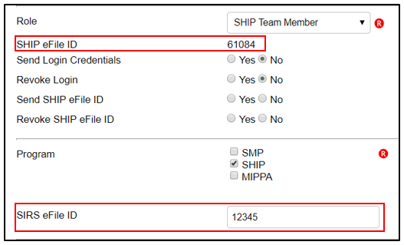
  - If the SIRS/SMP eFile ID is not present on the front end of the STARS/SHIP Team Member form as shown above, please log in with the SIRS/SMP credentials, navigate to the SIRS/SMP Team Member page of the desire Team Member to retrieve the SIRS eFile ID
Note: Multiple eFile IDs can be retrieved and exported to .xls by following the directions in the “Guidance for SHIP Directors: Creating an Advanced Search to Retrieve Multiple eFile IDs in Production” section

Guidance for SHIP Directors
- To access eFile IDs in the UAT environment, please follow the steps in the “Guidance for System Developers” section. If you do not have access to the test account information, please reach out to the proprietary system point of contact provided to ACL

Production Environment (https://acl.entellitrak.com)

Guidance for System Developers
  - Based on ACL guidance, Booz Allen will not provide credentials to the Production environment. Please reach out to the SHIP Director, SHIP Assistant Director, or another point of contact to retrieve any STARS/SHIP and SIRS /SMP eFile IDs

Guidance for SHIP Directors: Creating an Advanced Search to Retrieve Multiple eFile IDs in Production
  - Multiple eFile IDs can be retrieved and exported to .xls by creating an Advanced Search for STARS/SHIP Team Members. Please find a screenshot of a sample Advanced Search with the suggested criteria below. Edit these parameters as necessary
  - STARS
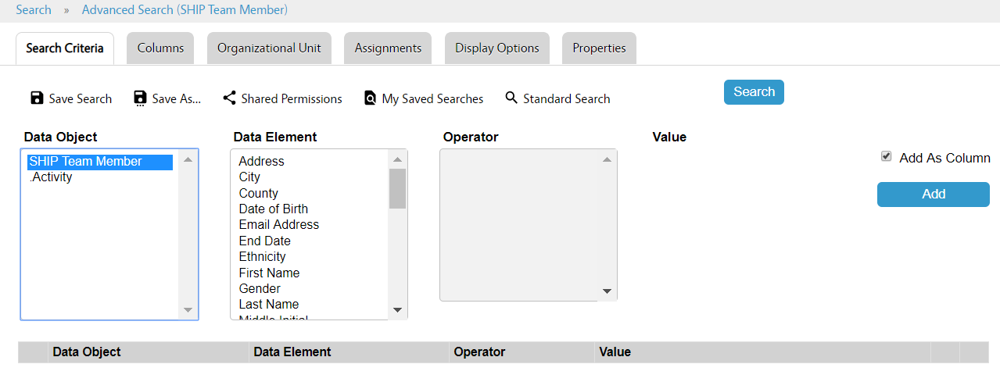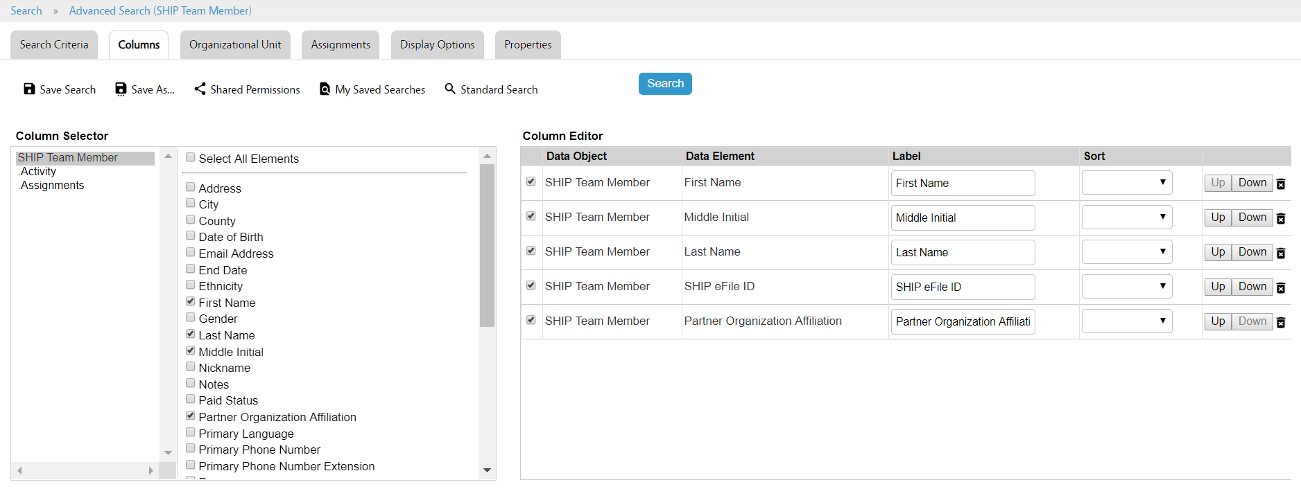
  - SIRS
